COMPUTER GRAPHICS

LAB ASSIGNMENT

SOHAM LAHIRI

002210501107

BCSE-UG3

JADAVPUR UNIVERSITY

Problem Statement 9: Implement Line Clipping with respect to a rectangular clip window, using Cohen Sutherland Algorithm.

Code:
const int INSIDE = 0; // 0000
const int LEFT = 1; // 0001
const int RIGHT = 2; // 0010
const int BOTTOM = 4; // 0100
const int TOP = 8; // 1000

// Function to compute region code for a point(x, y)
int MainWindow::computeCode(int xa, int ya)
{
int x_min=ui->x_min->value(),x_max=ui->x_max->value(),y_min=ui->y_min->value(),y_max=ui->y_max->value();

// initialized as being inside
int code = INSIDE;
if (xa < x_min) // to the left of rectangle
code |= LEFT;
else if (xa > x_max) // to the right of rectangle
code |= RIGHT;
if (ya < y_min) // below the rectangle
code |= BOTTOM;
else if (ya > y_max) // above the rectangle
code |= TOP;

return code;
}
// Implementing Cohen-Sutherland algorithm
// Clipping a line from P1 = (x1, y1) to P2 = (x2, y2)
void MainWindow::cohenSutherlandClip(int x1, int y1,int x2, int y2)
{
int x_min=clipper_points[0][0],x_max=clipper_points[2][0],y_min=clipper_points[0][1],y_max=clipper_points[2][1];
// Compute region codes for P1, P2
int code1 = computeCode(x1, y1);
int code2 = computeCode(x2, y2);

// Initialize line as outside the rectangular window
bool accept = false;

while (true)
{

if ((code1 == 0) && (code2 == 0))
{
// If both endpoints lie within rectangle
accept = true;
break;
}
else if (code1 & code2)
{
// If both endpoints are outside rectangle,
// in same region
break;
}
else
{
// Some segment of line lies within the
// rectangle
int code_out;
int x, y;

// At least one endpoint is outside the
// rectangle, pick it.
if (code1 != 0)
code_out = code1;
else
code_out = code2;

// Find intersection point;
// using formulas y = y1 + slope * (x - x1),
// x = x1 + (1 / slope) * (y - y1)
if (code_out & TOP)
{
// point is above the clip rectangle
x = x1 + (int)((double)(x2 - x1) *(double)(y_max - y1) /(double)(y2 - y1));
y = y_max;
}
else if (code_out & BOTTOM)
{
// point is below the rectangle
x = x1 + (int)((double)(x2 - x1) * (double)(y_min - y1) / (double)(y2 - y1));
y = y_min;
}
else if (code_out & RIGHT)
{
// point is to the right of rectangle
y = y1 + (int)((double)(y2 - y1) * (double)(x_max - x1) / (double)(x2 - x1));
x = x_max;
}
else if (code_out & LEFT)
{
// point is to the left of rectangle
y = y1 + (int)((double)(y2 - y1) * (double)(x_min - x1) / (double)(x2 - x1));
x = x_min;
}

// Now intersection point x,y is found
// We replace point outside rectangle
// by intersection point
if (code_out == code1)
{
x1 = x;
y1 = y;
code1 = computeCode(x1, y1);
}
else
{
x2 = x;
y2 = y;
code2 = computeCode(x2, y2);
}
}
}
if (accept)
{
//If accepted
//Just reset and draw the boundary and the line
//Reset the screen and draw the grid
// on_reset_clicked();
// draw_Window();
draw_dda_line(x1,y1,x2,y2,255,0,255);

}
else
{
//If not accepted
//Just reset and draw the boundary
//Reset the screen and draw the grid
draw_Window();
}

}

void MainWindow::on_line_cliping_clicked()
{
int x1 = ui->x1->value();
int x2 = ui->x2->value();
int y1 = ui->y1->value();
int y2 = ui->y2->value();
draw_dda_line(x1,y1,x2,y2,0,0,0);
cohenSutherlandClip(x1,y1,x2,y2);
}

EXPLANATION
Key Features of the Code
- Initialization of Constants and Input Handling
  - The code initializes region codes (INSIDE, LEFT, RIGHT, BOTTOM, TOP) to identify the relative position of a point concerning the clipping rectangle.
  - A function, computeCode, calculates the region code for a given point (xa, ya) based on user-defined boundaries for the clipping rectangle (x_min, x_max, y_min, y_max).
- Region Code Calculation
  - computeCode uses bitwise operations to assign a unique region code to a point depending on whether it lies inside, above, below, or outside the rectangle.
- Cohen-Sutherland Line Clipping Algorithm
  - The main function, cohenSutherlandClip, implements the Cohen-Sutherland algorithm, which:
    - Computes region codes for the two endpoints of the line.
    - Determines whether the line is entirely inside the rectangle, entirely outside, or partially inside.
  - Acceptance Criteria:
    - If both endpoints have a region code of INSIDE (0000), the line is fully inside the rectangle.
  - Rejection Criteria:
    - If the bitwise AND of the region codes for the two endpoints is non-zero, the line is completely outside the rectangle and is rejected.
- Intersection Calculation
  - If the line is partially inside:
    - The intersection point between the line and the rectangle boundaries is calculated using linear equations:
      - x=x1+(slope)⋅(y−y1)
      - y=y1+(1/slope)⋅(x−x1)
    - The region code of the endpoint outside the rectangle is updated with the new intersection point.
- Line Drawing
  - If the clipped line is accepted:
    - The clipped line is drawn using a DDA line-drawing algorithm with a specified color (magenta: RGB 255,0,255).
  - If rejected:
    - Only the rectangle (clipping window) is redrawn.
- Integration with GUI
  - The function on_line_clipping_clicked retrieves user-input line endpoints (x1, y1) and (x2, y2) from the GUI fields.
  - The initial line is drawn in black (0, 0, 0), followed by the clipping operation.

Key Steps in the Algorithm
- Calculate Region Codes
  - The function computeCode determines which region each endpoint belongs to using the clipping rectangle's boundaries.
- Iteratively Determine the Clipping
  - While loop iterates until the line is accepted or rejected:
    - Case 1: Both endpoints are inside the rectangle (accept immediately).
    - Case 2: Both endpoints are outside and share a common region (reject immediately).
    - Case 3: At least one endpoint is outside the rectangle (calculate intersections and update the line).
- Final Draw
  - After clipping, the function redraws the clipping window and, if accepted, the clipped line

Output:

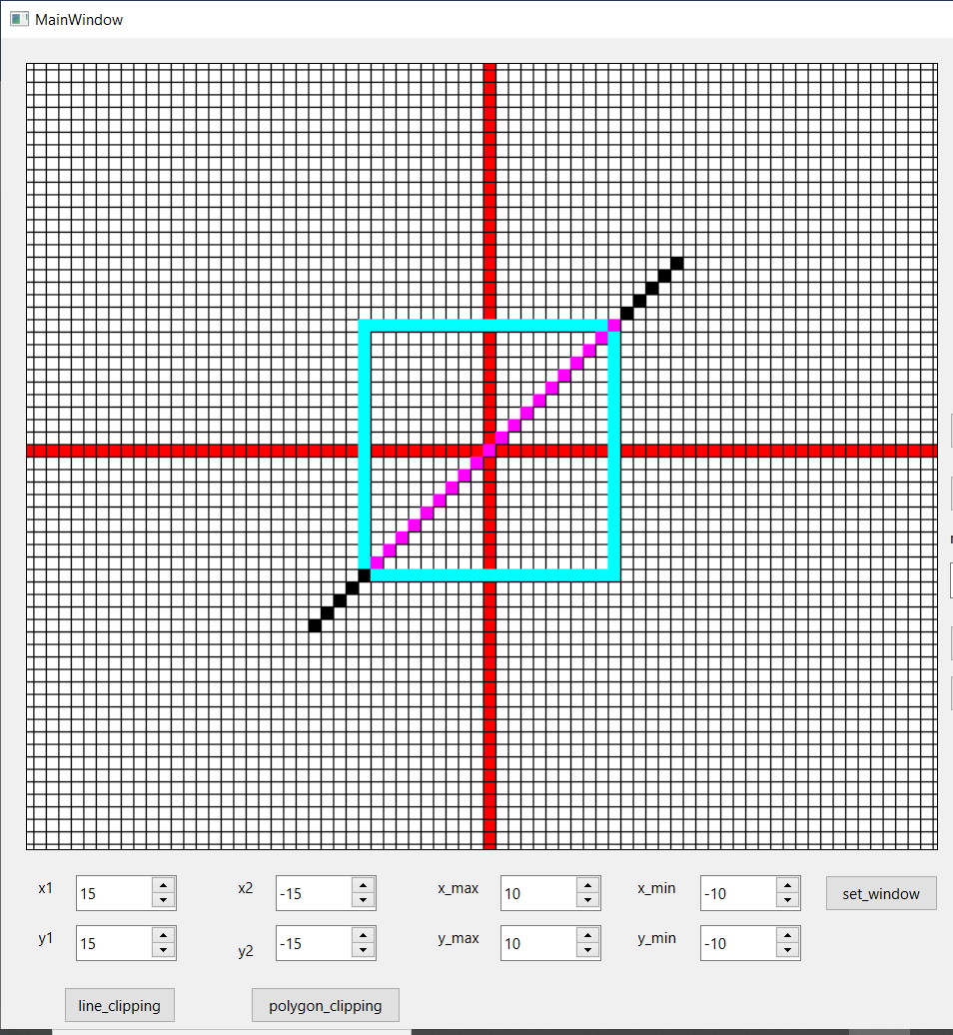

Problem Statement 10. Implement Polygon Clipping with respect to a rectangular clip window, using Sutherland-Hodgeman Algorithm.

Code:

const int MAX_POINTS = 20;

// Returns x-value of point of intersectipn of two
// lines
int MainWindow::x_intersect(int x1, int y1, int x2, int y2,int x3, int y3, int x4, int y4)
{
int num = (x1*y2 - y1*x2) * (x3-x4) -
(x1-x2) * (x3*y4 - y3*x4);
int den = (x1-x2) * (y3-y4) - (y1-y2) * (x3-x4);
return num/den;
}

// Returns y-value of point of intersectipn of
// two lines
int MainWindow:: y_intersect(int x1, int y1, int x2, int y2,int x3, int y3, int x4, int y4)
{
int num = (x1*y2 - y1*x2) * (y3-y4) -
(y1-y2) * (x3*y4 - y3*x4);
int den = (x1-x2) * (y3-y4) - (y1-y2) * (x3-x4);
return num/den;
}

// This functions clips all the edges w.r.t one clip
// edge of clipping area
void MainWindow:: clip(int x1, int y1, int x2, int y2)
{
int poly_size=vertex_list.size();
int new_poly_size = 0;

std::vector<QPoint> new_points;

// (ix,iy),(kx,ky) are the co-ordinate values of
// the points
for (int i = 0; i < poly_size; i++)
{
// i and k form a line in polygon
int k = (i+1) % poly_size;
int ix = vertex_list[i].x(), iy = vertex_list[i].y();
int kx = vertex_list[k].x(), ky = vertex_list[k].y();

// Calculating position of first and second point

int i_pos,k_pos;
if(x2==x1 && ix>x1) i_pos=1;
else if(x2==x1 && ix<x1) i_pos=-1;
else if(y2==y1 && iy<y1) i_pos=1;
else i_pos=-1;

if(x2==x1 && kx>x1) k_pos=1;
else if(x2==x1 && kx<x1) k_pos=-1;
else if(y2==y1 && ky<y1) k_pos=1;
else k_pos=-1;

if(y1>y2||x1>x2)
{
i_pos=(-1)*i_pos;
k_pos=(-1)*k_pos;
}

// Case 1 : When both points are inside
if (i_pos >= 0 && k_pos >= 0)
{
//Only second point is added
new_points.push_back(QPoint(kx,ky));
new_poly_size++;
}

// Case 2: When only first point is outside
else if (i_pos < 0 && k_pos >= 0)
{
// Point of intersection with edge
// and the second point is added

new_points.push_back(QPoint(x_intersect(x1,y1, x2, y2, ix, iy, kx, ky),y_intersect(x1,y1, x2, y2, ix, iy, kx, ky)));
new_poly_size++;

new_points.push_back(QPoint(kx,ky));
new_poly_size++;
}

// Case 3: When only second point is outside
else if (i_pos >= 0 && k_pos < 0)
{
//Only point of intersection with edge is added

new_points.push_back(QPoint(x_intersect(x1,y1, x2, y2, ix, iy, kx, ky),y_intersect(x1,y1, x2, y2, ix, iy, kx, ky)));
new_poly_size++;
}

// Case 4: When both points are outside
else
{
//No points are added
}
}

// Copying new points into original array
// and changing the no. of vertices
poly_size = new_poly_size;
vertex_list.clear();
for (int i = 0; i < new_points.size(); i++)
{
vertex_list.push_back(new_points[i]);
}
vertex_list.push_back(new_points[0]);
}

// Implements Sutherland–Hodgman algorithm
void MainWindow::suthHodgClip()
{
std::vector<QPoint> old_vertex;
for(int i=0;i<vertex_list.size();i++)
{
old_vertex.push_back(vertex_list[i]);
}
int clipper_size=4;
//i and k are two consecutive indexes
for (int i=0; i<clipper_size; i++)
{
int k = (i+1) % clipper_size;

// We pass the current array of vertices, it's size
// and the end points of the selected clipper line
clip(clipper_points[i][0],
clipper_points[i][1], clipper_points[k][0],
clipper_points[k][1]);
}
//on_reset_clicked();
//draw_Window();
//poly_draw2(old_vertex,0,0,0);
poly_draw2(vertex_list,255,0,255);

}

void MainWindow::poly_draw2(std::vector<QPoint>vertexes,int r, int g, int b) {
int n=vertexes.size();

for(int i=0;i<n;i++){
QPoint q1=vertexes[i],q2=vertexes[(i+1)%n];
draw_dda_line(q1.x(),q1.y(),q2.x(),q2.y(),r,g,b);
}
}

void MainWindow::on_polygon_clipping_clicked()
{
suthHodgClip();
}

EXPLANATION
Key Features of the Code
1. Initialization and Definitions
- The program implements the Sutherland-Hodgman Polygon Clipping algorithm to clip a polygon against a rectangular clipping window.
- It defines helper functions x_intersect and y_intersect to calculate the intersection points of a polygon edge with the clipping window edges.
2. Intersection Point Calculation
- x_intersect:
  - Calculates the x-coordinate of the intersection point between a polygon edge and the clipping window edge.
  - Utilizes the determinant formula for line intersection.
- y_intersect:
  - Calculates the y-coordinate of the intersection point using a similar determinant formula.
3. Edge Clipping Function
- clip(x1, y1, x2, y2):
  - Clips the polygon edges against a single edge of the rectangular clipping window.
  - For each polygon edge, it determines the positional relationship of the edge's endpoints relative to the clipping edge:
    - Inside (positive or zero position)
    - Outside (negative position)
  - Based on this positional relationship, it handles the following cases:
    - Case 1: Both endpoints inside → Add the second point to the clipped polygon.
    - Case 2: First point outside, second point inside → Add intersection point and the second point.
    - Case 3: First point inside, second point outside → Add the intersection point.
    - Case 4: Both points outside → No points added.
  - Updates the polygon with new vertices after clipping.
4. Sutherland-Hodgman Polygon Clipping
- suthHodgClip():
  - Clips the entire polygon against each edge of the rectangular clipping window.
  - Iterates over the four edges of the window, passing the current polygon and the clipper edge coordinates to the clip function.
  - After processing, the resulting polygon is the clipped polygon.
5. Polygon Drawing
- poly_draw2():
  - Draws the polygon using its vertex list and specified RGB color values.
  - Uses the DDA line algorithm to draw lines between consecutive vertices, ensuring smooth edges.
6. Polygon Clipping Trigger
- on_polygon_clipping_clicked():
  - Invokes the suthHodgClip() function to clip the polygon against the clipping window.
  - Visualizes the clipped polygon on the canvas by calling poly_draw2.

Algorithm Explanation
Sutherland-Hodgman Algorithm
- Input:
  - A polygon defined by a list of vertices.
  - A clipping window defined by its boundary edges.
- Process:
  - Iteratively clip the polygon against each boundary of the clipping window.
  - Each edge of the polygon is evaluated relative to the clipping edge, and new vertices are calculated as needed.
- Output:
  - A new polygon that lies entirely within the clipping window.

Code Flow
Step 1: Clipping Polygon Edges
- The clip function processes each polygon edge relative to a clipping edge:
  - Determines the intersection points (if any).
  - Filters out portions outside the clipping window.
Step 2: Sequential Clipping
- The suthHodgClip function iterates through all four clipping edges of the rectangular window.
- The polygon is progressively clipped, reducing its vertices with each step.
Step 3: Visualization
- The poly_draw2 function is used to visualize the resulting polygon.
- Unclipped and clipped polygons are drawn in different colors for comparison.

Output:
